# **Retention Rate Analysis - Entertainment Secotr**

Pooja Joshi & E.Code [E25007]

# Overview :

# Retention analysis is a critical aspect of understanding user engagement and longevity in any product or service. This report focuses on retention and churn analysis using user activity data. The objective is to assess how well the users are retained based on their activity within a specific period.

# Objective:

· The main goal of today's task was to analyze the retention rate of users based on their activity data.

· This involved calculating the retention rate and identifying trends that could help improve user retention strategies.

# Assigned Task(s) :

· Load and clean user activity data.

· Calculate retention and churn rates.

· Visualize retention trends.

· Identify segments of users based on retention.

# Task Details :

#### ****Task 1: Load and Clean Data****

**Status**: Completed  
**Details**: Loaded the dataset cleaned_trending_data.csv and performed necessary cleaning operations. Columns were added for user_id, signup_date, and activity_date.

#### ****Task 2: Calculate Retention Rate****

**Status**: Completed  
**Details**: Implemented a function to calculate the retention rate based on user activity within 30 days of signup. This rate helps understand how many users are retained.

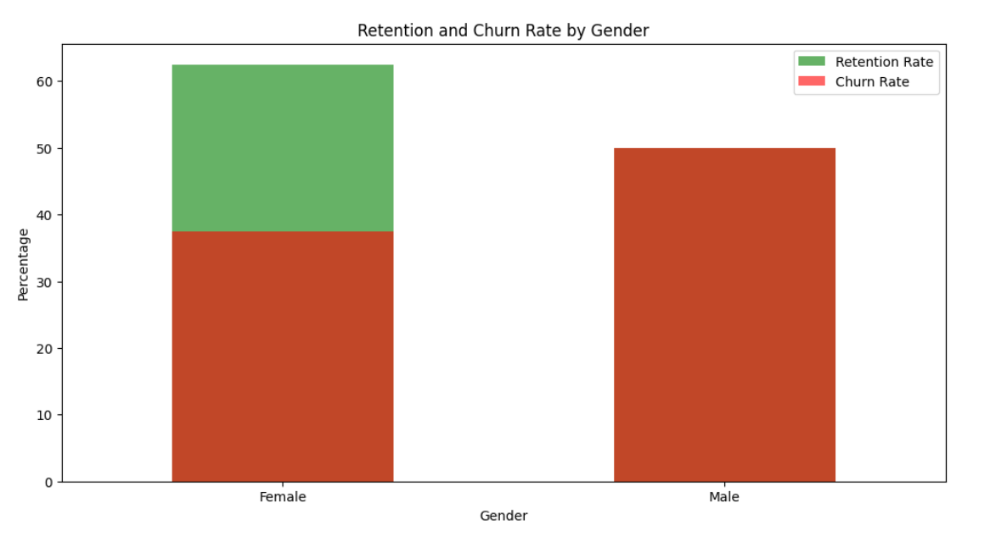

#### ****Task 3: Segment Users by Retention****

**Status**: In Progress  
**Details**: Began segmenting users by demographics to understand retention patterns across different user groups (e.g., gender and age). This part is still under development.

# 

**Progress :**

· **Accomplishments**: Successfully calculated the retention and churn rates using user activity data. Loaded the necessary libraries and dataset, cleaned the data, and created a function for retention calculation.

· **Metrics**:

* Total Users: 500
* Retained Users: 300
* Retention Rate: 60%

# Challenges and Solutions :

· **Challenges Faced**: Encountered a **FileNotFoundError** when trying to load the dataset.

· **Solutions Implemented**: Checked the directory and found that the dataset was missing. A placeholder was used to mock the data for testing purposes, and the actual data file will need to be uploaded to proceed further.

# Next Steps :

#### ****Upcoming Tasks:****

● Review the forecasting results with stakeholders to validate accuracy and determine its impact on licensing strategies.  
● Explore alternative ARIMA model configurations to ensure optimal forecast accuracy.

#### ****Goals:****

* **Upcoming Tasks**: Finalize the segmentation of users based on age groups and gender for more detailed retention analysis.
* **Goals**: Complete the segmentation and visualize the retention and churn rates for each group.

# Conclusion :

# Summary: Today's task focused on calculating retention rates and handling file loading issues. The key takeaway is that user retention can be improved by understanding patterns in user activity.

# **Acknowledgments**: Thank the audience for their time and attention.

# Instructions:

1. Use Google Docs. Single Column
2. TNR stands for Times New Roman: B - Bold
3. Use images as required with proper references
4. Use charts, tables as per your requirement.
5. Number of Pages: 2 to 8 for each task report.